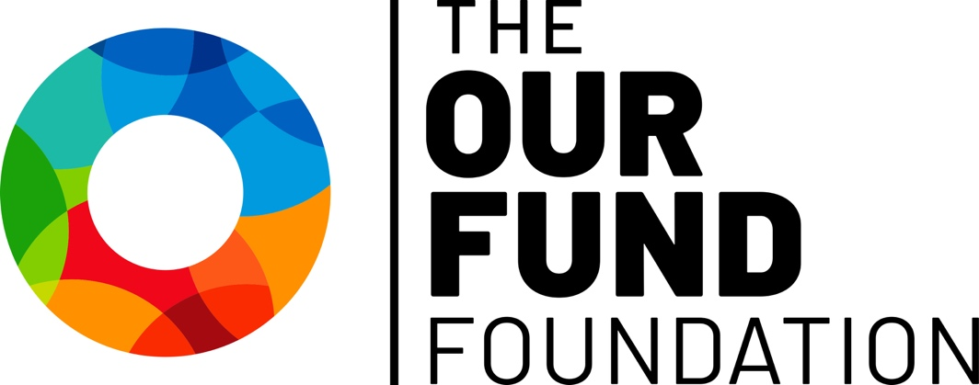

2026 LGBTQ Arts & Culture Fund
Request for Proposals

LOI Deadline: Friday, June 22, 2026 by 11:59 PM ET
Application Deadline: Friday, July 24, 2026 by 11:59 PM ET

The Our Fund Foundation
1201 NE 26TH Street, Suite 108
Wilton Manors, FL 33305
(954) 565-1090
TheOurFund.org
LGBTQ Arts & Culture Fund Grants Request for Proposals

The Our Fund Foundation’s mission is to make South Florida the most livable and thriving place in the country for members of the LGBTQ community.

The Values that define the Foundation’s promise to stakeholders and to our community:

- Facilitating Philanthropy: Committing to having a top-notch, respected, full-service community foundation to support donors’ wishes.
- Celebrating Generosity: Bringing those who have done well and are doing good to the forefront for their spirit of enriching lives.
- Epitomizing Collaboration: Fulfilling the role of a supportive, objective focal point for LGBTQ organizations and concerns.
- Responding Creatively: Supporting the LGBTQ community’s unique and timely needs with fresh thinking and new ideas.
- Valuing Diversity: Understanding that LGBTQ people’s struggles for equality is inextricably linked to other disenfranchised communities.
- Serving the Underserved: Promoting that the privilege of having means comes with the responsibility to lift up those most in need.
- Operating Transparently: Knowing that a person’s trust is the key to becoming their partner in carrying out their philanthropic priorities.

Our Fund Foundation LGBTQ Arts & Culture Fund

Our Fund Foundation recognizes the importance of arts and culture to inspire, empower and transform individuals and communities. Grants from this fund promote South Florida artistic expression that amplifies LGBTQ voices and works in the service of preserving, telling and celebrating LGBTQ stories and promoting LGBTQ equality and social justice.

Grants from the Fund are made possible through contributions from The Jim Laird Hamish Fund at The Our Fund Foundation, Our Fund Donor Advised Fundholders and individual donors, The Our Fund Foundation’s Endowment Fund, and the support of philanthropic partners.

Eligibility

Please note that an agency may submit or be a partner in only one proposal for an Arts & Culture Fund grant in a grant cycle.

To be eligible for a 2026 LGBTQ Arts & Culture Fund grant, your agency must:
- Be a non-profit 501(c)(3) organization or provide documentation that the organization is fiscally sponsored by an organization that has 501(c)(3) status.
- Be either:
  - A LGBTQ-primary organization (defined as an organization whose mission includes the LGBTQ population as the primary focus of their work; whose staff and board predominantly reflect the LGBTQ community; and which primarily serves LGBTQ people); or
  - A non-LGBTQ-primary organizations seeking funding for a LGBTQ-specific program/project.
- Request operational support for an organization or program/project in Broward or Miami-Dade Counties.
- Request support for a program/project occurring between September 1, 2026 to August 31, 2027.

Please note the following are not eligible for support:
- Requests for costs incurred prior to the date of the grant award
- Requests from government agencies
- Requests for capital support, including construction and renovation
- Fundraising event sponsorship
- Organizations with outstanding grant project reports

Special consideration will be given to:
- Organizations and projects that are organized by, and work on behalf of, underserved populations within the LGBTQ community (including ethnicity, race, age, gender, gender identity and physical and cognitive ability).
- Organizations that offer proof of pro-actively addressing gaps in representation of underserved populations in regard to board, staff, audience and user participation.
- Programs that have limited appeal to traditional funding sources.
- Applications that leverage partnerships between similar-missioned agencies to reduce duplication of effort/resources and expand reach/services.

Awards: The maximum Arts & Culture Fund grant award is $20,000.
LGBTQ Arts & Culture Fund
2026 Request for Proposals

The arts inhabit a vital and indispensable part of South Florida’s LGBTQ community, not just to inspire, but to build bridges in connection and understanding. The Our Fund Foundation seeks to continue supporting that valuable contribution with grants from the LGBTQ Arts & Culture Fund. With this application, Our Fund is asking arts and culture organizations to propose projects and continue work that can will be engaging with communities through 2026 and beyond. Projects should aim to incorporate and build upon strategies devised during uncertain times, while looking toward a path to resilience and sustainability in a changing cultural landscape of both challenges and opportunities.

Deadline and timeline
The Our Fund Foundation will accept only electronic submissions beginning June 1, 2026. The deadline for electronic LOI submission will be Monday, June 22, and the deadline for application submission will be Friday, July 24, 2026 at 11:59 PM.

Funding decisions will be announced by September 2026.

Application Process
After submitting the LOI, if your project is selected, you will be invited to submit a full application.
- Applicants invited to apply will also be required to schedule a brief applicant interview video before the application due date with the Grants Manager before being able to submit a complete application.
All applications are reviewed by Our Fund’s program staff and then by a diverse community panel. The panel makes recommendations to Our Fund Foundation’s Board of Directors.

LGBTQ Arts & Culture Fund Application
Organizational Information
Name of Organization *
Email Address *
Mailing Address *
City *
State *
Zip Code *
Website
FEIN Number *
Contact Person *
Phone Number *
Fiscal Sponsor (if applicable)
Address
Phone Number

LOI
Project Name
Amount Requested
Project Description
Organizational Expertise
Proposal Narrative
Please address each of the following components:
(1500 character limit for each answer)
- Project Proposal
  - Project Title
  - Amount Requested
    - Amount requested for project proposal. $20,000 limit
  - Project Duration
    - Project Start Date
    - Project End Date
  - Project Summary
    - Please summarize your project in one brief descriptive sentence.
- Project Description
    - Please provide a detailed description of the program for which you are seeking funds.
- Program Design
- Serving a Diverse Community
  - Describe the target audience for this project and what efforts will be undertaken to engage with them.
- Timeline
  - Please include timeline with clearly defined tasks.
- Community Collaboration
  - Describe any efforts to collaborate with similar or related community projects, and if there are community partners.
- Organizational Strength/Capacity
- Organizational Expertise
  - Please explain your organization’s experience and/or expertise and how it makes it uniquely positioned to deliver the proposed project. If your organization is a non-LGBTQ-primary organization, please include the percentage of your projects that are directed at the LGBTQ population.
- List of Board Members
  - Please list your current board of directors, including their professional affiliations and the general racial-ethnic composition.
- Non-discrimination Policy
- Leadership Succession Plan
- Budget & Budget Justification
- Budget Justification
  - In narrative form, describe specifically how your budget will support the activities described. Include a description of additional sources of income needed to complete program and whether additional sources are confirmed or planned.
- Financial Statements
  - Most recent audited financial statements
- Form 990
  - Most recent Form 990 Tax Filing
- IRS Letter of Determination
  - IRS Letter of Determination tax exemption under Section 501 (c)(3)
- Operating Budget
- Project Budget
- Donor Listing
  - A list of foundations, corporations, governmental agencies, and individuals who funded the organization in the last fiscal year ($1,000 and above for agencies with budgets <$500,000 / $5,000 and above for agencies >$500,000)
- Project Budget Adjustment
- Impact/Outcomes
- Project Evaluation
  - Describe measurable outcomes expected and the methods to be used in evaluating the success of the desired outcomes.

