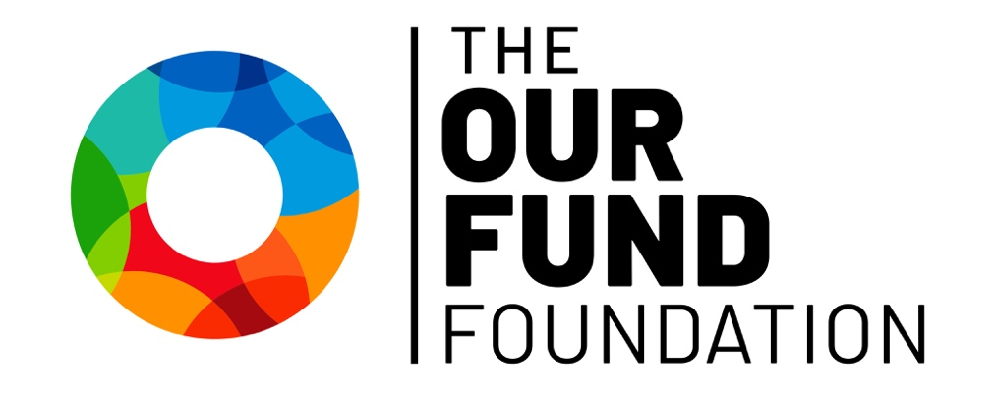

LGBTQ Health & Wellness Fund
2026 Request for Proposals

LOI Deadline: Friday, August 21, 2026
Application Deadline: Friday, September 25, 2026 by 11:59 PM ET

The Our Fund Foundation
1201 NE 26TH Street, Suite 108
Wilton Manors, FL 33305
(954) 565-1090
TheOurFund.org

LGBTQ Health & Wellness Fund Grants Request for Proposals

Our Fund’s mission is to secure the LGBTQ community’s future by promoting and increasing responsible philanthropy, strengthening community organizations and their leaders and connecting donors to causes that matter.

The Values that define Our Fund’s promise to stakeholders and to our community:

- Facilitating Philanthropy: Committing to having a top-notch, respected, full-service community foundation to support donors’ wishes.
- Celebrating Generosity: Bringing those who have done well and are doing good to the forefront for their spirit of enriching lives.
- Epitomizing Collaboration: Fulfilling the role of a supportive, objective focal point for LGBTQ organizations and concerns.
- Responding Creatively: Supporting the LGBTQ community’s unique and timely needs with fresh thinking and new ideas.
- Valuing Diversity: Understanding that LGBTQ people’s struggles for equality is inextricably linked to other disenfranchised communities.
- Serving the Underserved: Promoting that the privilege of having means comes with the responsibility to lift up those most in need.
- Operating Transparently: Knowing that a person’s trust is the key to becoming their partner in carrying out their philanthropic priorities.

The Our Fund Foundation LGBTQ Health & Wellness Fund

The Our Fund Foundation’s Health & Wellness Fund invests in the collective vision of what a healthy LGBTQ community in South Florida can and should be.

With health equity as a driving force, Our Fund strives for health and wellness outcomes that allow LGBTQ people in South Florida to live full, healthy and happy lives. To this end, Our Fund Foundation’s Health & Wellness Fund supports agencies and initiatives that address the unique issues affecting the wellness of LGBTQ people in South Florida and close the disparities that LGBTQ people face resulting from social stigma and discrimination.

Applicants for support from Our Fund’s Health & Wellness Fund should indicate a health and wellness concern(s) and the affected population and provide an intervention, service or project that improves the health and wellness of LGBTQ people in South Florida.

Grants from the Fund are made possible through contributions from Our Fund Donor Advised Fundholders and individual donors, Our Fund’s Endowment Fund, and the support of philanthropic partners.

Eligibility

Please note that an agency may submit or be a partner in only one proposal for a Health & Wellness Fund grant in a grant cycle.

To be eligible for a 2026 Our Fund Foundation Health & Wellness Fund grant, your agency must:
- Be a non-profit 501(c)(3) organization or provide documentation that the organization is fiscally sponsored by an organization that has 501(c)(3) status.
- Be either:
  - A LGBTQ-primary organization (defined as an organization whose mission includes the LGBTQ population as the primary focus of their work; whose staff and board predominantly reflect the LGBTQ community; and which primarily serves LGBTQ people); or
  - A non-LGBTQ-primary organizations seeking funding for a LGBTQ-specific project.
- Request support for an organization or project in Broward or Miami-Dade.
- Request support for a project or activities occurring in calendar year 2027.

Please note the following are not eligible for support:
- Requests for costs incurred prior to the date of the grant award
- Requests from government agencies
- Requests for capital support, including construction and renovation
- Fundraising event sponsorship
- Organizations with outstanding grant project reports

Special consideration will be given to:
- Organizations and projects that are organized by, and work on behalf of, underserved populations within the LGBTQ community (including ethnicity, race, age, gender, gender identity and physical and cognitive ability).
- Organizations that offer proof of pro-actively addressing gaps in representation of underserved populations in regard to board, staff, and project participant.
- Applications that leverage partnerships between similar-missioned agencies to reduce duplication of effort/resources and expand reach/services.

Awards: The maximum Health & Wellness Fund grant award is $40,000 (1-year period).

Deadline and timeline
Grant Overview will be held virtually on Tuesday, July 21 at 10:00 AM. Organizations interested in applying for and receiving grants from the LGBTQ Health & Wellness Fund are encouraged to attend to have questions answered about the application, process and priorities for the LGBTQ Health & Wellness Fund grants. A recording will be made available after the date of the meeting.

The Our Fund Foundation will begin accepting LOI proposals electronically through our online portal beginning August 3, until August 21. The LOI will consist of an introductory paragraph describing your proposal, and a paragraph describing your organization. Organizations whose proposals are accepted will be invited to fill out the full application starting August 31 with a deadline of September 25 at 11:59 PM.

- Applicants invited to apply will also be required to schedule a brief applicant interview video before the application due date with the Grants Manager before being able to submit a complete application.

Funding decisions will be announced and grant awards will be made in January 2027.

Review Process
All applications are reviewed by Our Fund Foundation’s staff and then by a diverse community panel. The panel makes recommendations to Our Fund Foundation’s Board of Directors. If your proposal is selected to move to the next part of the process, an interview will be scheduled with the review panel.

LGBTQ Health & Wellness Fund Application

Organizational Information
Name of Organization *
Email Address *
Mailing Address *
City *
State *
Zip Code *
Website
FEIN Number *
Contact Person *
Phone Number *
Fiscal Sponsor (if applicable)
Address
Phone Number

LOI
Project Name
Amount Requested
Project Description
Organizational Expertise

Project Proposal Narrative Please address each of the following components.
Agencies seeking general operating support can do so for mission-related projects and services.
(1500 character limit for each answer)
- Project Details
  - Are you using a Fiscal Sponsor?
  - Have you received funding on a prior project for the LGBTQ Health & Wellness Fund?
    - Is there an outstanding report for this grant due?
    - Report Due: Please provide a date for when the outstanding report will be submitted (N/A if previously submitted or not due yet)
  - Project Title
  - Amount Requested: Amount requested for project proposal. $40,000 limit
  - Project Start Date:
  - Project End Date:
  - Health & Wellness Concern
    - Indicate a health concern

- Project Proposal
  - Project Summary: please summarize your project in one brief descriptive sentence.
  - Project Description: Please provide a detailed description of the project you are proposing.
- Project Design
  - Serving a Diverse Community: LGBTQ community members whose identities intersect with underrepresented groups (including race, ethnicity, age, gender, and physical and cognitive ability) often experience disparities in comparison to their cis/white peers and are consequently underserved. Explain how your project serves the needs of a diverse and/or underrepresented community.
  - Timeline: Please include timeline with clearly defined tasks.
  - Community Collaboration: Describe any efforts to collaborate with similar or related community projects
- Organizational Strength/Capacity
- Organizational Expertise: Please explain your organization’s experience and/or expertise and how it makes it uniquely positioned to deliver the proposed project. If your organization is a non-LGBTQ-primary organization, please include the percentage of your projects that are directed at the LGBTQ population.

- List of Board Members: Please list your current board of directors, including their professional affiliations and the overall racial-ethnic composition.

- Non-discrimination Policy

- Leadership Succession Plan

- Impact/Outcomes
- Project Evaluation: Describe measurable outcomes expected and the methods to be used in evaluating the success of the desired outcomes.
- Budget & Budget Justification
- Budget Justification: In narrative form, describe specifically how your budget will support the activities described. Include a description of additional sources of income needed to complete project and whether additional sources are confirmed or planned.
- Financial Statements: Most recent audited financial statements
- Form 990: Most recent Form 990 Tax Filing
- IRS Letter of Determination: IRS Letter of Determination of tax exemption under Section 501(c)(3) of the Internal Revenue Code
- Operating Budget
- Project Budget
- Donor Listing: A list of foundations, corporations, governmental agencies, and individuals who funded the organization in the last fiscal year ($5,000 and above for agencies with budgets <$500,000 / $25,000 and above for agencies >$500,000)
- Project Budget Adjustment: In the event that you do not receive a full grant, how will the project be adjusted ​to accommodate?

